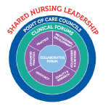

Meeting Name: Nurse BootCamp for CICU Nurses
Date: 9/16/25
Time: 0730-1130
Location: 2nd Floor Main Building, Vision Center
Call In Number:
Agenda Topic | Discussion Lead | Time
Welcome | All
Cardiopulmonary Interactions | Dr. Justine Mize Fortkiewicz | 0730-0800
Advanced Ventilation Concepts | Dr. Craig Futterman | 0800-0845
Advanced Surgical Considerations | Dr. Manan Desai | 0845-0930
Break |  | 0930-0945
Modifiable Stressors in the CICU | Melissa Jones, NP | 0945-1015
CICU Case Studies | Sarah Wilson, NP | 1015-1115
Debrief | All | 1115-1130

