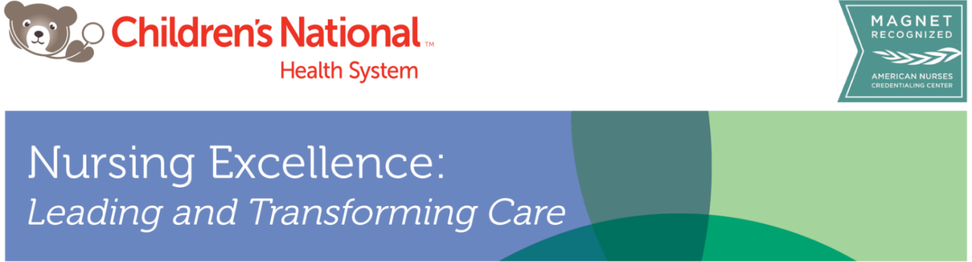

**Preceptor Workshop (2025)**

0800-1200

|  |  |  |
| --- | --- | --- |
| **Time** | **Topic** | **Faculty** |
| 8:00 – 8:10 | **Preceptor Program Overview** | **Ashley Moore, MSN-Ed., RN, CPN**  *Professional Development Specialist in NEPD* |
| 8:10 – 9:35 | **I-COACH Model Overview,**  **Emotional Intelligence, and Preceptor as Socializer** |
| 9:35 – 9:50 | **BREAK** |
| 09:50 – 10:15 | **Preceptor as Role Model** |
| 10:15 – 11:00 | **Preceptor as Educator**  **Adult Learning Principles** |
| 11:00 – 11:10 | **BREAK** |
| 11:10 – 11:30 | **Biweekly Check-ins and Competency Validation Checklists** |
| 11:30 -11:55 | **Coming Together: Feedback, Communication and Conflict Management in the Preceptor Role** |
| 11:55 – 12:00 | Closing Remarks and Evaluations |

*“A good preceptor inspires people to have confidence in him or her. A great preceptor inspires people to have confidence in themselves.”* - Anonymous